# Section 4.4: The Mean Value Theorem

The Mean Value Theorem is one of the most important theorems in calculus. The Mean Value Theorem says that for a function that meets its conditions, at some point the tangent line has the same slope as the secant line between the ends. For this function, there are two values $c_{1}$ and $c_{2}$ such that the tangent line to $f$ at $c_{1}$ and $c_{2}$ has the same slope as the secant line.

## The Mean Value Theorem and Its Meaning

**Mean Value Theorem**

Let $f$ be continuous over the closed interval $[a,b]$ and differentiable over the open interval $(a,b)$. Then, there exists at least one point $c∈(a,b)$ such that

$f^{'}\left(c\right)=\frac{f\left(b\right)-f(a)}{b-a}$.

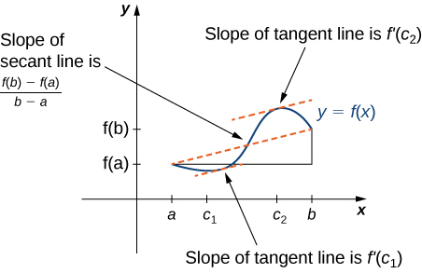

Media: Watch this [video](https://youtu.be/o_9waQrwPes) example on the Mean Value Theorem of a quadratic function.

Media: Watch this [video](https://youtu.be/VF_vgEC1G6o) example on the Mean Value Theorem of a rational function.

Examples

1. For $f\left(x\right)=\sqrt{x}$ over the interval $[0,9]$, show that $f$ satisfies the hypothesis of the Mean Value Theorem, and therefore there exists at least one value $c∈(0,9)$ such that $f^{'}(c)$ is equal to the slope of the line connecting $(0, f\left(0\right))$ and $(9, f\left(9\right))$. Find the values $c$ guaranteed by the Mean Value Theorem.
2. If a rock is dropped from a height of $100 ft$, its position $t$ seconds after it is dropped until it hits the ground is given by the function $s\left(t\right)=-16t^{2}+100$.
   1. Determine how long it takes before the rock hits the ground.
   2. Find the average velocity $v_{\text{avg}}$ of the rock for when the rock is released, and the rock hits the ground.
   3. Find the time $t$ guaranteed by the Mean Value Theorem when the instantaneous velocity of the rock is $v_{\text{avg}}$.